Category: Medium

Contest: Not yet used in any contest

Question:

KJSCE Team was working with government civil engineers to build a highway between Khandala and Mahabaleshwar. But the hills between the two cities were quite unpredictable in structure. The team had cost constraints hence wanted to do minimum hill cutting, tunnelling, support building and bridge building work. Assuming the two hill stations to be nearly at the same altitude, a straight line was drawn between them.

Model used to picture the road:

The line was 150km long. There were planes drawn after every d distance perpendicular to the line. The plane line intersection was taken as the origin. The origin was always observed to lie inside a hill so to build the shortest highway the points on the surface of the hill closest to the origin were marked. X axis was taken as a line passing through the origin, in the plane and parallel to the horizontal. Y axis was taken as a line passing through the origin, in the plane and perpendicular to the horizontal plane. As according to safety regulations the highway must not turn by more than tan-12 in the horizontal plane and not more than tan-13/2 in the vertical plane.

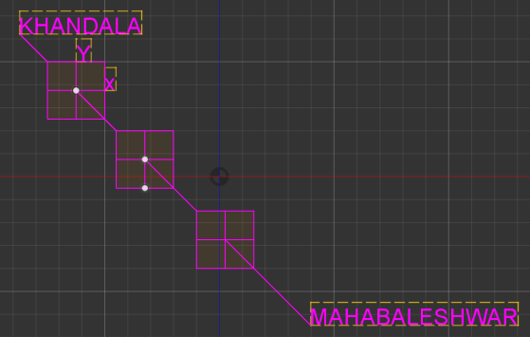

If the coordinates of these closest points are given, state minimum number of hill cuttings, support building, tunnelling and bridge building processes needed in total if:

A tunnel is built when the point needs to be shifted along –x

A support is built when the point needs to be shifted along +y

A bridge needs to be built if the point needs to be shifted along +x

A hill cutting is done when the point needs to be shifted along -y

If a point is shifted in any two ways together then both the corresponding processes will be needed.

Input:

d distance of plane separation: real positive number

x and y coordinates of all the marked points: real number

Output:

Number of tunnels + Number of supports + Number of Bridges + Number of Hill Cuttings

Example:

|  |  |
| --- | --- |
| Input | Output |
| 20  1 1  2 2  100 100  3 3  -100 -100  5 5  6 6 | 4 |

Explanation:

The points (100,100) and (-100,-100) are too far to follow the angle regulations. So 1 support and 1 bridge is needed for (-100,-100). Similarly 1 tunnel and 1 hill cutting is needed for (100,100).

Try these inputs:

|  |  |
| --- | --- |
| Input | Output |
| 20  1 1  2 2  100 100  3 3  -100 -100  5 5  6 6 | 4 |
| 10  1 1  2 2  3 3  4 4  5 5  6 6  7 7  8 8  9 9  10 10  11 11  12 12  13 13  14 14 | 0 |
| 15  100 100  -100 -100  100 100  -100 -100  100 100  -100 -100  100 100  -100 -100  100 100  -100 -100 | 12 |
| 30  0 0  1 1  2 2  100 100 | 2 |
| 45  50 50  50 50  100 100 | 0 |
| 15  0 0  10 10  100 100  200 200  100 100  10 10  0 0  -10 -10  100 -100 | 10 |